**PROJECT REPORT TEMPLEATE**

**BUILD AN EVENT MANAGEMENT USING SALESFORCE SYSTEM**

**TEAM ID:NM2023TMID20765**

**1.INTRODUCTION**

**1.1 Overview:**

An Event Management System provides campus event planners a flexible, fully integrated solution to simplify the event management process and keep your customers, faculty and students happy, while maintaining important reports and data for making real estate and future planning decisions.

**1.2 Purpose**

* The host organization
* Host community
* Co-workers
* Event sponsors
* Media
* Participants and speatators

**2. Problem Definition & Design Thinking**

An empathy map is a collaborative visualization used to articulate what we know about a particular type of user. If externalizes knowledge about users in order to

1. Create a shared understanding of user needs, and
2. Aid in decision making.

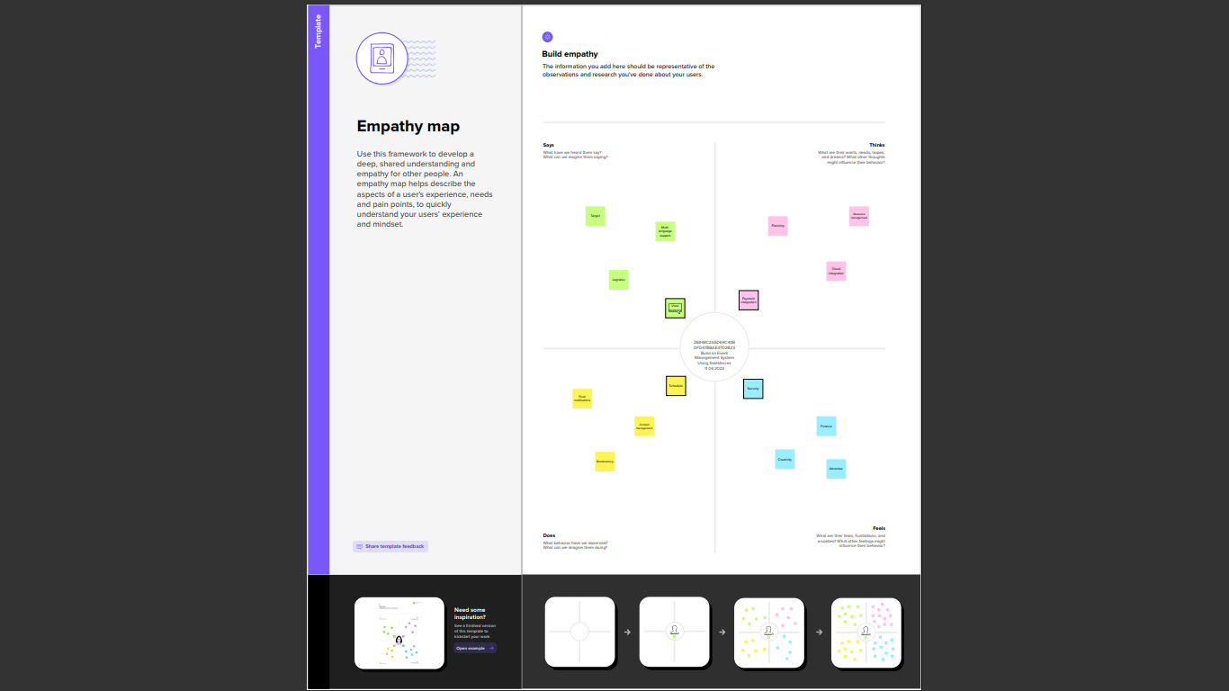

2.2 Brainstorming:

Brainstorming is a group problem-solving method that involves the spontaneous contribution of creative ideas and solutions. This technique requires intensive, freewheeling discussion in which every member of the group is encouraged to think aloud and suggest as many ideas as possible based on their diverse knowledge.

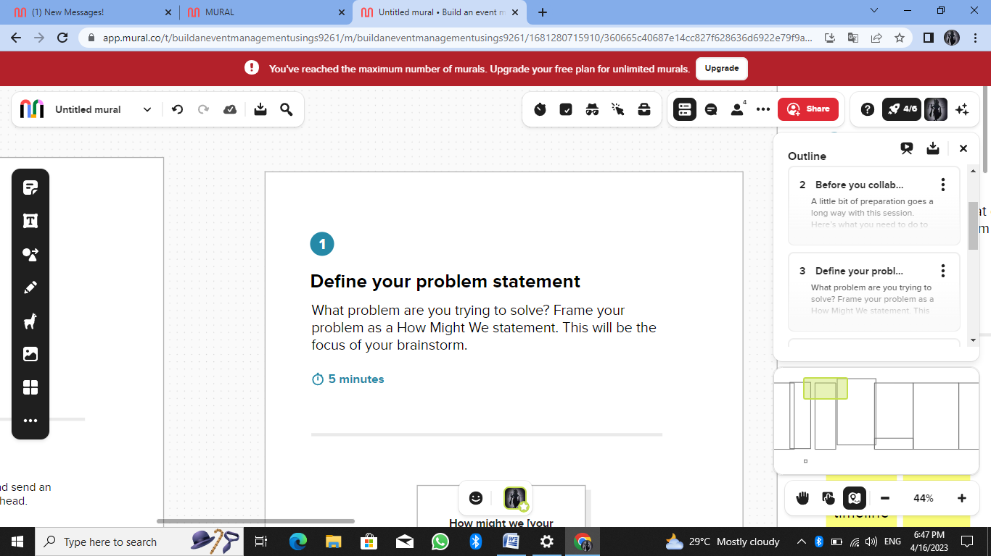

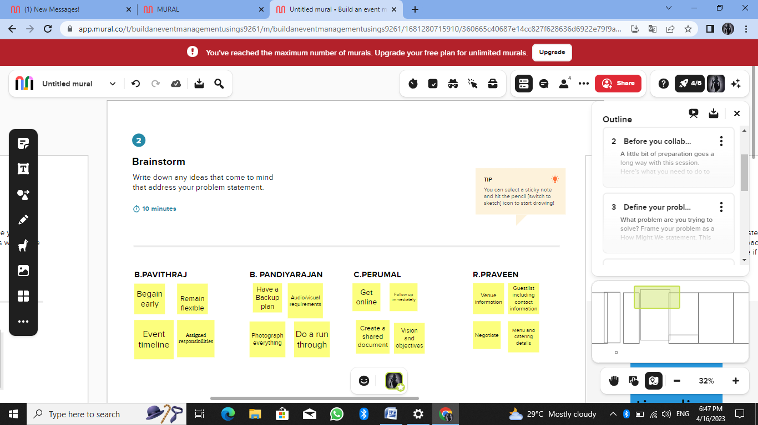

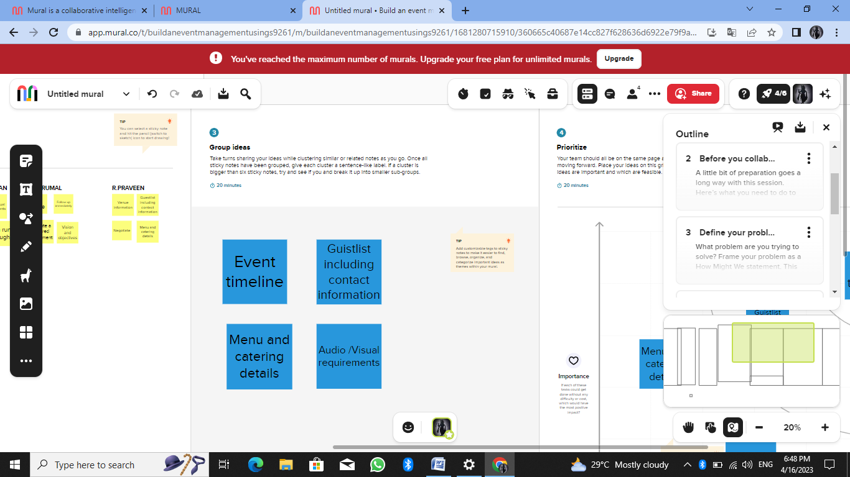

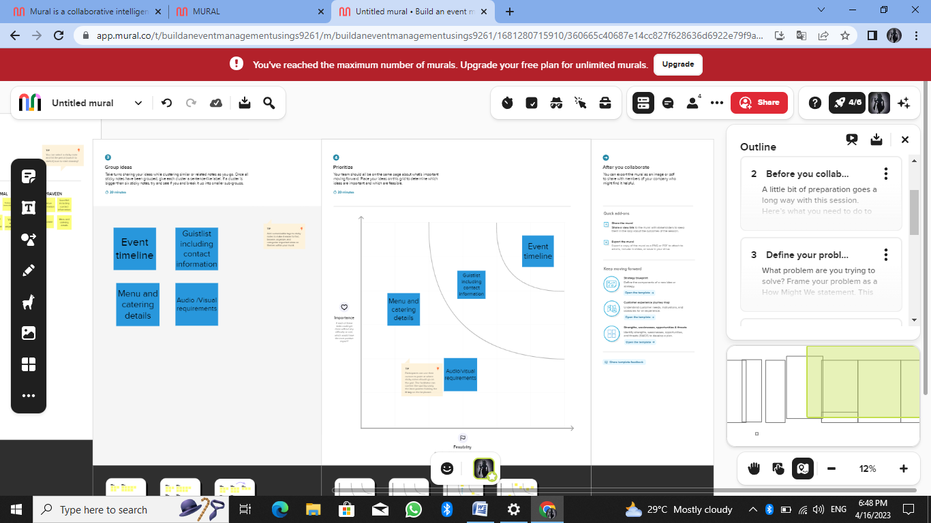

3. **RESULT**

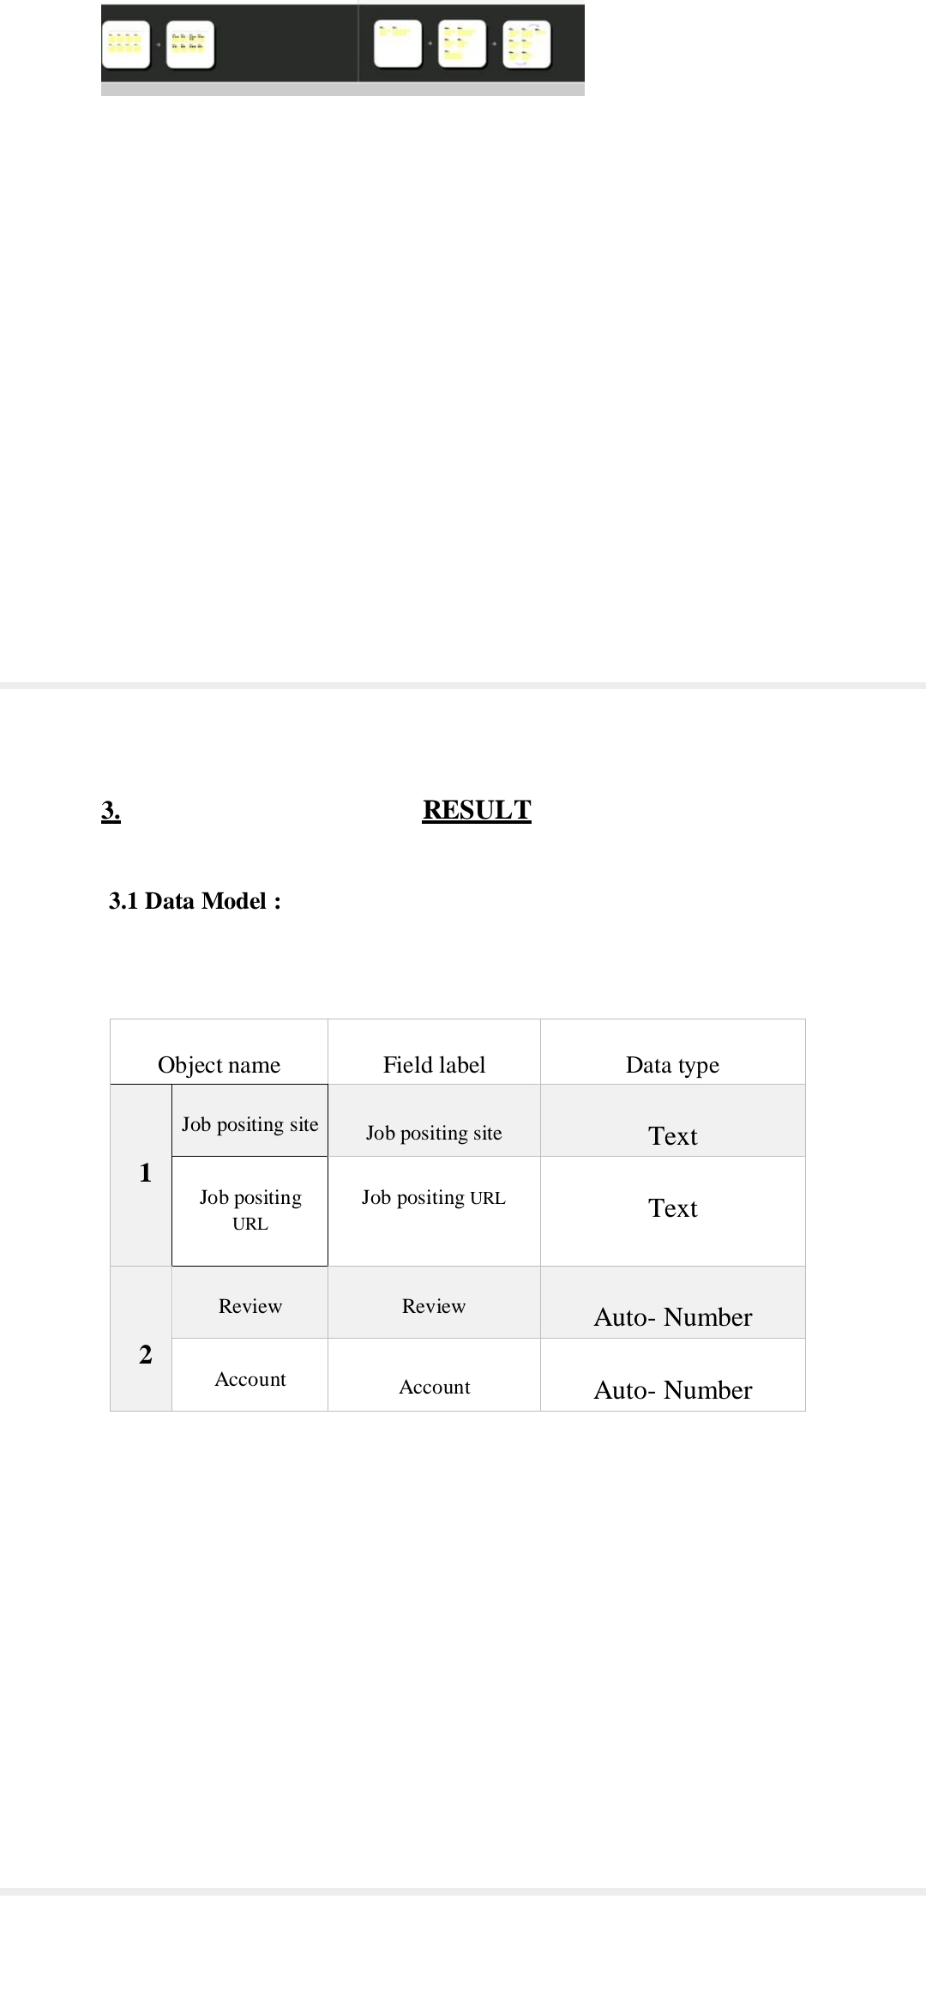

3.2 Activity & Screenshot:

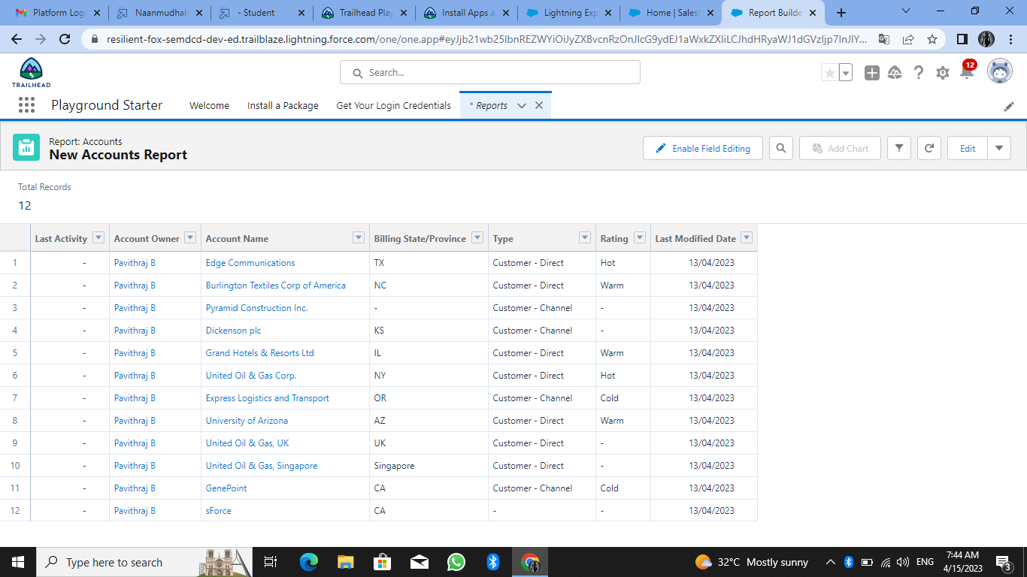

TRAILHEAD PROFILE PUBLIC URL

Team Leader - <https://trailblazer.me/id/pavib23>

Team Member 1 [- https://trailblazer.me /id/ppradeeban](-%20%20https:/trailblazer.me%20/id/ppradeeban)

Team Member 2 - <https://trailblazer.me/id/cperumal3>

Team Member 3 - <https://trailblazer.me/id/pandiyarajan1718>

Advantages:

* Best event planning
* End to end execution
* Improve customer services and satisfaction
* Smooth execution of planned ideas
* Saves time and money
* Maintain best account history
* Easy to manage.

**Disadvantages:**

* Sponsor may request changes in rules, equipment, start times etc.
* There are not always suited to the performs.

5. **APPLICATIONS**

* An event management company will save you and your team late nights, headaches and the hassles of organising the event yourself.
* Event managers bring a lot of experience into play which means you can be confident that your event will be a success.
* Expert planning and budget management to ensure overall event success.
* Technology that gives your attendees a professional and slick journey.
* In particular business clients appreciate full attention from their hosts and are open to building relationships and planning future business endeavours during an event.

**6. CONCLUSION**

From a business perspective, event management is of great importance. Creating events occasionally provide an incredible opportunity to promote one’s business. Be studying events management, you’ll be set up with skills that won’t just help you succeed in this particular career path, but will set you up with a whole host of transferrable skills and experiences, such as handling budgets, running marketing campaigns, and managing people and logistics.

**7.** **FUTURE SCOPE**

The project has a very vast scope in future. Event management involves studying the intricacies of the brand, identifies the target audience, devising the event concept, planning the logistics and coordinating the technical aspects before actually executing the modalities of the proposed event.